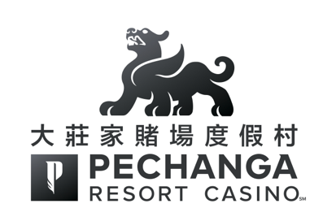

「大莊家賭場度假村」榮獲四大主流媒體讀者票選為
多項「加州最佳」殊榮

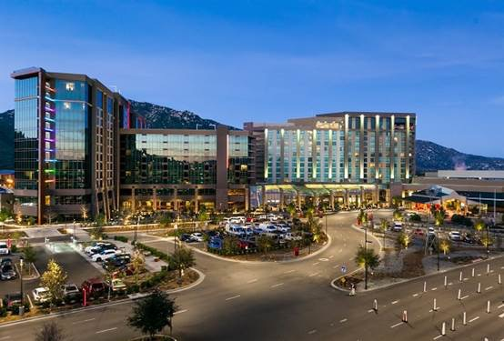
2018年3月三億元新擴建的「大莊家賭場度假村」外觀
最近，全美各大傳媒報刊舉行各項投票選舉活動，讓讀者評選各自心頭喜愛的博彩娛樂場以及最喜愛的博彩娛樂場設施，包括酒店、水療護理、高爾夫球場、餐廳及更多其他的選舉項目。主流權威媒體如「USA Today」、「Orange County Register」、「Press-Enterprise」及「SoCal Gaming Guide」邀請讀者們使用數分鐘時間參與投票，而選舉結果極具公信力及清晰。

在「Orange County Register」期刊讀者關於南加州最佳活動及娛樂的評選中，「大莊家賭場度假村」榮獲「南加州最佳賭場」。這項殊榮正突顯「大莊家」擴建後新增的酒店大樓擁有568間酒店客房及套房，一座豪華獨立的水療護理中心，兩家星級餐飲食府，還有佔地達68,000平方呎的會議展覽及活動場地，以及面積達4.5英畝的「The Cove」綜合性游泳池項目。

「Press-Enterprise」報章涵蓋南加州內陸帝國地區，讓讀者能在數十項類別中票選出本地區最受歡迎的項目。「大莊家賭場度假村」榮獲讀者票選為「最喜愛的南加州博彩娛樂場」，而「大莊家」籏下的「Kelsey’s」酒吧獲選為「最佳體育主題酒吧」，以及附設的著名餐廳「Umi」壽司生蠔吧更在「食評家心選」類別中獲選為「最佳壽司餐廳」。

而在極具權威性的「USA Today」報章旗下網站10Best.com亦舉行全國性票選，「大莊家」獲得三個類別的最佳提名，包括「拉斯維加斯以外的最佳博彩娛樂場」，「全美最佳博彩娛樂場酒店」，及「全美最佳博彩娛樂場餐廳」（「Umi」壽司生蠔吧）。選舉結果顯示，「大莊家」在拉斯維加斯以外地區及全美最佳餐廳評選中，「Umi」壽司生蠔吧榮獲「全美最佳博彩娛樂場餐廳」第二名，而「大莊家」並同時獲得「最佳博彩娛樂場酒店」第三名以及「拉斯維加斯以外的最博彩娛樂場」第四名。除此以外，「Umi」壽司生蠔吧亦成為西岸唯一獲得提名的博彩娛樂場餐廳。
在「Southern California Gaming Guide」讀者民意調查中，讀者受邀在數十項類別為本地區博彩娛樂場及相關項目評分。而最終結果顯示，「大莊家」被票選為「最佳博彩娛樂場度假村」、「最佳娛樂」、「最佳撲克」、「最佳水療」及「最佳博彩娛樂場高爾夫球場」等多個最佳頭銜。

眾所周知，「大莊家賭場度假村」為最理想的休閒度假及博彩娛樂勝地，由洛杉磯開往「大莊家」只需要兩小時車程，聖地牙哥僅需約一小時車程。「大莊家」擁有四鑽級豪華酒店及休閒娛樂設施，最貼心的款客服務，讓您體驗星級娛樂，享受尊貴禮遇。

如欲了解更多詳情，或預訂「大莊家賭場度假村」酒店房間及其他服務，請登錄Pechanga.com或致電專線 (877) 711-2946。

大莊家賭場度假村匯集精彩多姿的娛樂
「大莊家賭場度假村」為美國其中之一間最大規模及提供最尊貴的賭場度假體驗。榮獲USA Today 讀者票選為全美最佳賭場第一名。並自2002年起一直被AAA評為四鑽級酒店，無論是日間玩樂還是豪華住宿，「大莊家賭場度假村」總會帶給您無與倫比的悠閒度假環境，擁有超過4,500多部最新潮角子老虎機，賭桌娛樂，頂級娛樂節目，1,090間豪華酒店客房，星級餐飲食府，讓您煥發身心的水療護理，以及世界錦標賽級的Journey高爾夫球場。「大莊家賭場度假村」致力滿足客人及社區的需求，並與時俱進超越期許。魯瑟諾印第安人中的Pechanga族人擁有並經營「大莊家賭場度假村」。更多詳情，請致電免費專線 (877) 711-2946，或登錄www.Pechanga.com。 點擊喜歡大莊家賭場度假村 Facebook網頁，以及Twitter@PechangaCasino。

PECHANGA RESORT CASINO CEMENTS “BEST IN CALIFORNIA”
STANDING IN 4 MAJOR READERS’ POLLS

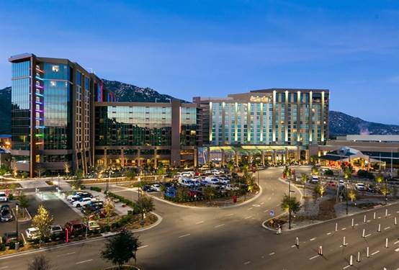
Pechanga Resort Casino after $300 million expansion completion in March 2018
Readers across the country were recently asked to rate their favorite casinos, and their favorite things within those casinos – hotel, spa, golf course, restaurants and more. Enthusiasts of USA Today, Orange County Register, Press-Enterprise and the So Cal Gaming Guide were asked to take a few minutes to cast their ballots, and readers spoke loud and clear.

In the Orange County Register’s readers’ poll in which they asked readers to rate the best activities and entertainment in Southern California, Pechanga took the top spot earning the title of Best Southern California Casino. The award highlighted Pechanga’s new expansion that added another 568 hotel rooms and suites, a luxury, two-level spa, two new restaurants, another 68,000-square feet of event space and the 4.5-acre pool complex called The Cove.

The Press-Enterprise, covering the Inland Empire region of Southern California, encouraged its readers to vote in dozens of categories to rank their favorite things in the area. Readers chose Pechanga Resort Casino as their favorite Southern California Casino and Kelsey’s as the best sports bar. Umi Sushi & Oyster Bar received a prestigious nod as a “Critic’s Choice” selection for best sushi restaurant.

The national contest put on by USA Today’s 10Best.com nominated Pechanga in three categories - Best Casino Outside Las Vegas, Best Casino Hotel and Best Casino Restaurant (Umi Sushi & Oyster Bar). Out of field of internationally acclaimed restaurants in Las Vegas and elsewhere, Umi took second place. Pechanga came in third place in the Best Casino Hotel category and fourth in the Best Casino Outside Las Vegas poll. Umi was the only West Coast casino restaurant nominated.

In the Southern California Gaming Guide’s readers’ poll, readers were asked to rate dozens of categories pertaining to regional casinos. Pechanga picked up first place wins in the categories of Best Casino Resort, Best Entertainment, Best Poker, Best Spa, and Best Casino Golf Course.

Guests know Pechanga Resort Casino as a destination where they can relax or take in the casino excitement with a less than two-hour drive from Los Angeles and about a one-hour drive from San Diego. Pechanga offers AAA Four Diamond accommodations, service, warmth and style in a relaxed, approachable luxury environment.

For more information or to make reservations at Pechanga Resort Casino, visit Pechanga.com or call (877) 711-2946.

About Pechanga Resort Casino
Pechanga Resort Casino offers one of the largest and most expansive resort/casino experiences anywhere in the country. Named the number one casino in the country by USA TODAY and rated a Four Diamond property by AAA since 2002, Pechanga Resort Casino provides an unparalleled getaway, whether for the day or for an extended luxury stay. Offering more than 4,500 of the hottest slots, table games, world-class entertainment, 1,090 hotel rooms, dining, spa and golf at Journey at Pechanga, Pechanga Resort Casino features a destination that meets and exceeds the needs of its guests and the community. Pechanga Resort Casino is owned and operated by the Pechanga Band of Luiseño Indians. For more information, call toll free (877) 711-2946 or visit www.Pechanga.com. Follow Pechanga Resort Casino on Facebook and on Twitter @PechangaCasino.

